**Additional Exercise**

**Problem Statement 1: [50 marks]**

**Two-tailed test for difference between two population means**

**Is there evidence to conclude that the number of people travelling from Bangalore to Chennai is different from the number of people travelling from Bangalore to Hosur in a week, given the following:**

**Population 1: Bangalore to Chennai**

**n1 = 120**

**1 = 452**

**s1 = 212**

**Population 2: Bangalore to Hosur**

**n2 = 800**

**2 = 523**

**s2 = 185**

**Solution:**

Given samples from two normal populations of size n1 and n2 with unknown means 1 and 2 and known standard

deviations  and, the test statistic comparing the means is known as the two-sample z statistic

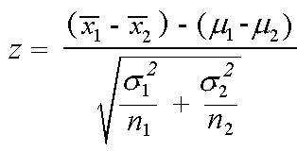

*T*= (Observed difference in sample means)−(Hypothesized difference in population means)

Standard error

H0 =  1 -  2 =0

H1 =  1 - 2 ≠ 0

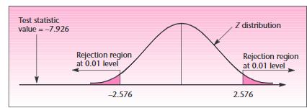

Z = (**452–523) - 0**

* + (2122/120)– (1852/800)
* - 7.926

The computed value of the Z-statistic falls in the left-hand rejection region for any commonly used , and the p-value is very small.

We conclude that there is a statistically significant difference in the means of the population who are travelling between the Bangalore to Chennai and Housur.

Hence, We reject Null Hypothesis

**Problem Statement 2: [50 marks]**

**Is there evidence to conclude that the number of people preferring Duracell battery is different from the number of people preferring Energizer battery, given the following:**

**Population 1: Duracell**

**n1 = 100 ; x1 = 308 ; s1 = 84**

**Population 2: Energizer**

**n2 = 100 ; x2 = 254 ; s2 = 67**

Solution:

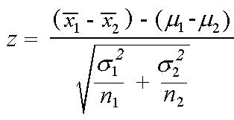

H0 =  1 -  2 =0

H1 =  1 - 2 ≠ 0

Z = (**308–254) - 0**

* + (842/100)– (672/100)
* 0.838

There is no proper evidence that people prefer Duracell over Energizer, hence we reject the null hypothesis.

**Problem Statement 3: [100 marks]**

**Pooled estimate of the population variance**

**Does the data provide sufficient evidence to conclude that average percentage increase in the price of sugar differs when it is sold at two different prices?**

**Population 1: Price of sugar = Rs. 27.50**

**n1 = 14 ; x1 = 0.317% ; s1 = 0.12%**

**Population 2: Price of sugar = Rs. 20.00**

**n2 = 9 ; x2 = 0.21% ; s2 = 0.11%**

Solution:

H0 =  1 -  2 =0

H1 =  1 -  2 ≠ 0

Significance level=5%

df=21 : critical value=2.080

t = (-0.317–0.210 ) - 0

* + (13(0.12)2+ (8)(0.11)2(1/14+ (1/9) 21
* 2.15

We reject the null hypothesis since, critical region should be <2.080

**____________________________________________________________________**

**Problem Statement 4: [100 marks]**

**The manufacturers of compact disk players want to test whether a small price reduction is enough to increase sales of their product. Is there evidence that the small price reduction is enough to increase sales of compact disk players**?

Population 1: Before reduction

n1 = 15 ; x1 = Rs. 6598; s1 = Rs. 844

Population 2: After reduction

n2 = 12 ; x2 = RS. 6870 ; s2 = Rs. 669

H0 =  1 -  2 =0

H1 =  1 -  2 ≠ 0

Significance level=5%

df =21 : critical value=2.060

t = (6870 - 6598) - 0

* + (14(844)2+ (11)(699)2(1/15+ (1/12) 21
* 0.91

This value of the statistic falls inside the non-rejection region for any usual level of significance. Hence, we accept the Null Hypothesis

**Problem Statement 5: [100 marks]**

**Comparisons of two population proportions when the hypothesized difference is zero. Carry out a two-tailed test of the equality of banks’ share of the car loan market in 1980 and 1995.**

Population 1: 1980

n1 = 1000 ; x1 = 53 ; p̂1 = 0.53

Population 2: 1985

n2 = 100; x2 = 43; p̂2= 0.53

Solution:

H0 = p 1 - p 2 =0

H1 = p 1 - p 2 ≠ 0

* (0.53-0.43)/SQRT((0.48*(0.52)*(0.01+0.01)))
* 1.41534

**Problem Statement 6: [100 marks]**

**Carry out a one-tailed test to determine whether the population proportion of traveler’s check buyers who buy at least $2500 in checks when sweepstakes prizes are offered as at least 10% higher than the proportion of such buyers when no sweepstakes are on.**

Population 1: With sweepstakes

n1 = 300 ; x1 = 120 ; p̂1 = 0.40

Population 2: No sweepstakes

n2 = 700 ; x2 = 140 ; p̂2= 0.20

H0:p1-p2<=0.10

H1:p1-p2>0.10

z at 1% is 2.33



* ((0.4-0.2)-0.1)/SQRT(((0.4*0.6)/300)+(0.2*0.8)/700)
* 3.1180

So rejecting the null hypothesis

__________________________________________________________________________

**Problem Statement 7: [100 marks]**

**A die is thrown 132 times with the following results:**

**Number turned up: 1, 2, 3, 4, 5, 6**

**Frequency: 16, 20, 25, 14, 29, 28**

**Is the die unbiased? Consider the degrees of freedom as p̂− 1.**

Solution:

**Problem:**

Number turned up: 1, 2, 3, 4, 5, 6

Frequency: 16, 20, 25, 14, 29, 28

**Hypothesis:**

h0:dice is biased

h1:dice is unbiased

df : 5

Significance

level:5% : 11.07

|  |  |  |  |
| --- | --- | --- | --- |
| freq | EF(np) | (0bs-ef)2 | X2cal |
| 16 | 22 | 36 | 9 |
| 20 | 22 | 4 |  |
| 25 | 22 | 9 |  |
| 14 | 22 | 64 |  |
| 29 | 22 | 49 |  |
| 28 | 22 | 36 |  |
|  |  | 198 |  |

Since the calculated value is less than observed value, so fail to reject null Hypothesis

**Problem Statement 8: [100 marks]**

**In a certain town, there are about one million eligible voters. A simple random sample of 10,000 eligible voters was chosen to study the relationship between gender and participation in the last election. The results are summarized in the following 2X2 (read two by two) contingency table:**

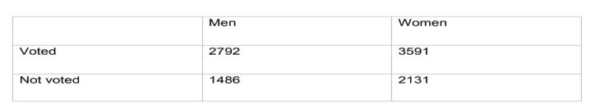

**We would want to check whether being a man or a woman (columns) is independent of having voted in the last election (rows). In other words, is “gender and voting independent”?**

|  |  |  |  |  |  |
| --- | --- | --- | --- | --- | --- |
| **Solution:** | |  |  |  |  |
|  | Details | | Men | Women | Total |
|  | Voted | | 2792 | 3591 | 6383 |
|  | Not voted | | 1486 | 2131 | 3617 |
|  |  |  | 4278 | 5722 | 10000 |

|  |  |
| --- | --- |
| Calculation of Chi square | |
| (o-E)^2 | Chi |
| 1.37848 | 6.660455899 |
| 2.432633 | |
| 1.030607 | |
| 1.818736 | |

|  |  |  |
| --- | --- | --- |
| Workings: |  |  |
| Expected | 2730.6474 | 3652.353 |
| DF:(2-1)*(2-1)=1 | 1547.3526 | 2069.647 |

Inference: Since p-value is between 0 and 1 % so we reject the null hypothesis

**Problem Statement 9: [100 marks]**

**A sample of 100 voters are asked which of four candidates they would vote for in an election. The number supporting each candidate is given below:**

|  |  |  |  |
| --- | --- | --- | --- |
| **Higgins** | **Reardon** | **White** | **Charlton** |
| **41** | **19** | **24** | **16** |

**Do the data suggest that all candidates are equally popular? [Chi-Square = 14.96, with 3 df, p̂< 0.05].**

Solution:

DF=(4-1)=3

Significance level=5 %

Chi table value=7.82



**Workings**

|  |  |  |
| --- | --- | --- |
| Expected(np) | (O-E)^2 | (o-E)^2/E |
| 25 | 256 | 10.24 |
|  | 36 | 1.44 |
|  | 1 | 0.04 |
|  | 81 | 3.24 |
|  |  | 14.96 |

Inference: Our obtained Chi-Square value 14.96 >7.82, and so we conclude that people do not prefer candidate equally

**Problem Statement 10: [100 marks]**

**Children of three ages are asked to indicate their preference for three photographs of adults. Do the data suggest that there is a significant relationship between age and photograph preference? What is wrong with this study? [Chi-Square = 29.6, with 4 df: p̂<0.05].**

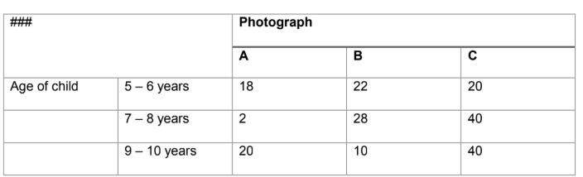

**Solution:**

|  |  |  |  |
| --- | --- | --- | --- |
| A | B | C | Overall |
| 18 | 22 | 20 | 60 |
| 2 | 28 | 40 | 70 |
| 20 | 10 | 40 | 70 |
| 40 | 60 | 100 | 200 |

Workings : DF=(3-1)*(3-1)=4

|  |  |  |  |  |  |  |  |
| --- | --- | --- | --- | --- | --- | --- | --- |
| Expected | | |  |  |  |  |  |
|  | Table | |  | (o-E)^2/E |  |  | chi |
| 12 | 18 |  | 30 | 3 | 0.8888889 | 3.3333333 | 29.6 |
|  |  |  |  |  |  |  |  |
| 14 | 21 |  | 35 | 10.285714 | 2.3333333 | 0.7142857 |  |
| 14 | 21 |  | 35 | 2.5714286 | 5.7619048 | 0.7142857 |  |

Inference: Critical value at .01 significance level and df 4 is 13.28 which is less than our calculated value. Hence, we find no significant relationship.

**Problem Statement 11: [100 marks]**

**A study of conformity using the Asch paradigm involved two conditions: one where one confederate supported the true judgement, and another where no confederate gave the correct response.**

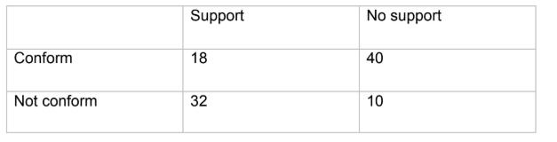

**Is there a significant difference between the "support" and "no support" conditions in the frequency with which individuals are likely to conform? [Chi-Square = 19.87, with 1 df: p̂< 0.05].**

Solution:

|  |  |  |  |
| --- | --- | --- | --- |
|  |  | no |  |
|  | support | support | Overall |
| confirm | 18 | 40 | 58 |
| not confirm | 32 | 10 | 42 |
|  | 50 | 50 | 100 |

Calculations: DF = 1

|  |  |  |  |  |  |  |  |
| --- | --- | --- | --- | --- | --- | --- | --- |
|  |  |  |  |  | (|o-E|- |  |  |
| Expected | |  | (|o-E|-0.5)^2 |  | 0.5)^2 /E |  | chi- Square |
| 29 |  | 29 | 110.25 | 110.25 | 3.801724 | 3.801724 | 18.1 |
| 21 |  | 21 | 110.25 | 110.25 | 5.25 | 5.25 |  |

Inference: Calculated chi square value is higher than chi square table value at .01 significance level at df 1(6.63) ,hence, this concludes that there is statistical difference between support and no support situation.

**Problem Statement 12: [100 marks]**

**We want to test whether short people differ with respect to their leadership qualities (Genghis Khan, Adolf Hitler and Napoleon were all stature-deprived, and how many midget MP's are there?) The following table shows the frequencies with which 43 short people and 52 tall people were categorized as "leaders", "followers" or as "unclassifiable". Is there a relationship between height and leadership qualities? [Chi-Square = 10.71, with 2 df: p̂< 0.01].**

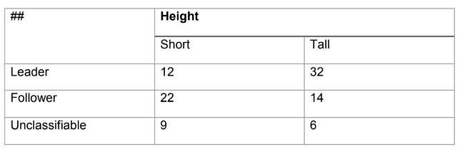

**Solution:**

|  |  |  |  |  |
| --- | --- | --- | --- | --- |
| Short |  | Tall |  | Overall |
|  | 12 |  | 32 | 44 |
|  | 22 |  | 14 | 36 |
|  | 9 |  | 6 | 15 |
|  | 43 |  | 52 | 95 |

**Calculations: for df:(3-1)*(2-1)=2**

|  |  |  |  |  |
| --- | --- | --- | --- | --- |
| Expected Table | | (o-E)^2/E |  | Chi |
| 19.92 | 24.08 | 3.146233 | 2.601693 | 10.712 |
| 16.29 | 19.71 | 1.997579 | 1.651844 |  |
| 6.79 | 8.21 | 0.719706 | 0.595142 |  |

**Inference**: Since the calculated value of Chi-square value 10.712 is higher than critical value at df 2 at significance level .01.

Hence we conclude that there is a significant relationship between height and leadership.

**Problem Statement 13: [100 marks]**

**Each respondent in the Current Population Survey of March 1993 was classified as employed, unemployed, or outside the labor force. The results for men in California age 35-44 can be cross-tabulated by marital status, as follows:**

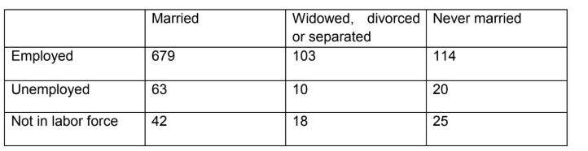

**Men of different marital status seem to have different distributions of labor force status. Or is this just chance variation? (you may assume the table results from a simple random sample.)**

|  |  |  |  |  |  |  |  |  |  |  |  |  |  |  |
| --- | --- | --- | --- | --- | --- | --- | --- | --- | --- | --- | --- | --- | --- | --- |
| **Solution:** |  |  |  |  |  |  |  |  |  |  |  |  |  |  |
|  | |  |  |  |  |  |  |  |  | |  |  |  |  |
| Married | |  |  | Widowed | |  | Never Married | | Overall | | |  |  |  |
| 679 |  |  |  | 103 |  |  | 114 |  |  | 896 | |  |  |  |
| 63 |  |  |  | 10 |  |  | 20 |  |  | 93 | |  |  |  |
| 42 |  |  |  | 18 |  |  | 25 |  |  | 85 | |  |  |  |
| 784 |  |  |  | 131 |  |  | 159 |  |  | 1074 | |  |  |  |
| Calculations: | | | | | | |  |  |  |  |  |  |  |  |
| DF=(3-1)*(3-1)=4 | | | | | | |  |  |  |  |  |  |  |  |
| At significance level 1% =13.28 | | | | | | | |  |  |  |  |  |  |  |
|  |  |  |  |  |  |  |  |  |  |  |  |  |  |  |
|  |  |  |  |  |  |  |  |  |  |  |  |  |  | Chi |
|  |  | Expected Table | | | | |  | (o-E)^2/E | |  |  |  |  | Square |
| 654.0633 | |  | 109.2886 | |  |  | 132.648 | 0.950731 | |  | 0.361858 | | 2.621596 | 31.61 |
| 67.88827 | |  | 11.34358 | |  |  | 13.76816 | 0.351978 | |  | 0.159138 | | 2.820703 |  |
| 62.04842 | |  | 10.36778 | |  |  | 12.5838 | 6.477829 | |  | 5.618435 | | 12.25084 |  |

Inference: Since the calculated value is way greater than at 1%, we conclude there is some dependency between marital and job